Adjusting your emis to changing conditions
Participant Workbook

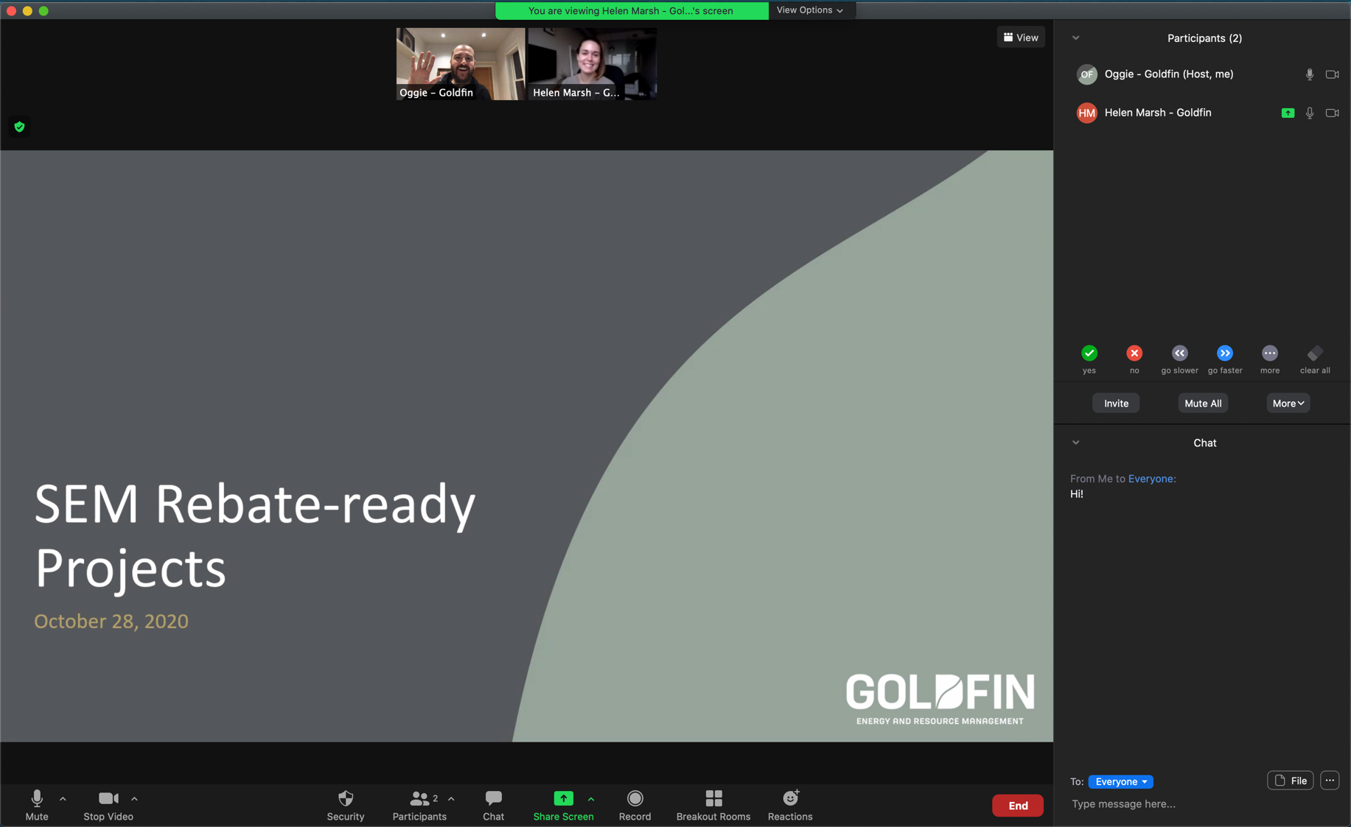
This workshop will be hosted via Microsoft Teams.
For instructions or troubleshooting please
see the last page of this workbook.
This 90-minute working session focuses on how to keep your Energy Management Information System (EMIS) aligned as your facility changes over time. Participants will work directly from their own systems, identify where drift is occurring, and leave with a clear starting point for maintaining EMIS reliability.
The focus is on real conditions, real system behaviour, and one practical next step rather than theory.

In this workshop, Participants will:
- Diagnose EMIS alignment with your current organizational needs
- Identify and interpret the causes and signs of EMIS drift
- Apply a structured approach to maintaining EMIS reliability and supporting action

WHAT has changed in your organization?
Facilities do not stay the same. Equipment is replaced, schedules shift, and operations evolve over time. EMIS is often not updated at the same pace, which creates a gap between system outputs and reality.

What has changed in your facility in the last 12 months?
List 2–4 changes that have not been reflected in your EMIS.

What is emis drift?
EMIS Drift = The gap between what your system thinks is happening and what is happening in your facility.
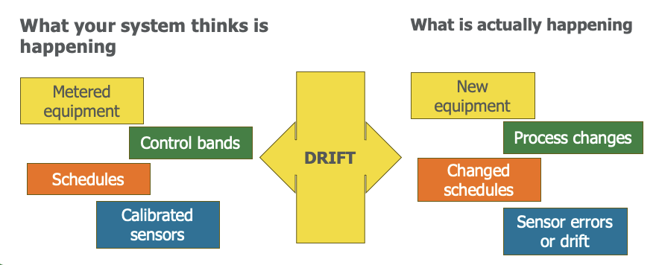

Why this Matters
EMIS drift can cause real challenges for your energy management efforts:
- Poor decisions from acting on incorrect data
- Missed savings as issues go undetected
- People stop using EMIS as trust is eroded
- Operational instability as controls and KPIs are misaligned
- Compliance risk (GHG, ESG, ISO 50001)

Potential drift in your emis
If your system has not been updated, it may no longer reflect current operations. Instead, it may be applying current data to how the facility used to operate.
For each change you listed: What impact could those changes have on your use of the EMIS?

Recent changes | What might be the impact this is having on your EMIS?

Where drift comes from
Drift type | Where is this occurring in your facility? | Has the EMIS updated to reflect this change?
Physical
- Equipment replaced or upgraded
- New systems installed
- Process changes
Operational
- Shift schedules change
- Production levels change
- Operating strategies evolve
Measurement
- Sensors uncalibrated, recalibrated, or replaced
- Data points renamed or removed
- New meters added
Organizational
- Roles and responsibilities shift
- SOPs not updated
- Outputs not reaching the right people

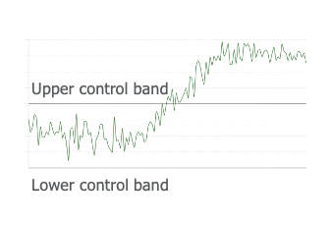
COMMON SIGNS OF DRIFT
Changing trends or unaligned baselines
- Baselines or control bands no longer match actual energy use
- Trend lines shift unexpectedly
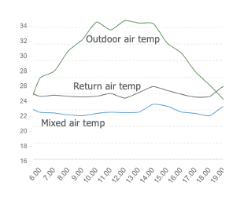

meter issues
- Data points missing or change name
- Meter or sensor readings don’t make sense
- Stuck or zeroed sensor outputs

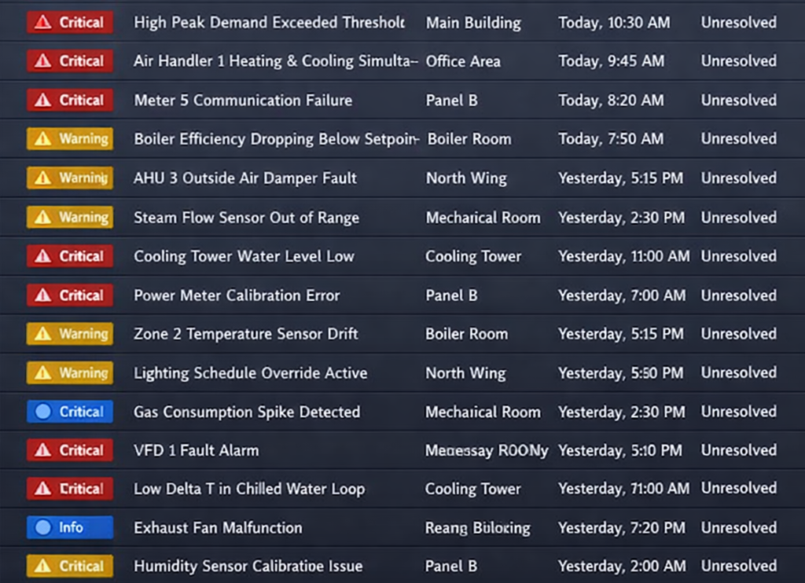
behaviour
- People ignoring alerts
- People no longer acting on report results
- Teams stop reviewing EMIS reports

which signs of drift are you seeing?

Signs | Yes/No | Where?
KPIs that no longer “feel right”
Sudden step changes without explanation
Increasing overrides or ignored alarms
Growing gap between EMIS and utility bills
Operators bypassing the system

What an aligned emis looks like
- That the facility is constantly changing; across physical, measurement, operational, and organizational dimensions.
- The EMIS is structured to reflect that through data, models, alerts, and outputs.
- In a well-aligned system, those two things stay connected.
- The system reflects current reality, not how the facility used to operate.
Physical
Operational
Measurement
Organizational
Facility changes (continuous)
EMIS
Data
Baseline models
Alerts
Outputs and reports

Notes


EMIS drift prevention framework

Part 1: EMIS SUSTAINMENT foundations

Define ownership and accountability
Who, specifically, owns your EMIS today?
Who is responsible for data quality?
Who is responsible for system operations?
Who is responsible for energy performance?
Responsibilities include:
- Updating baselines, KPIs, control bands, alerts, etc.
- Validating meters and maintaining meter inventory
- Reviewing anomalies to determine cause (EMIS issue or operational issue)
- Making sure changes to facility or operations are being captured and addressed

Integrate EMIS with change management systems
When something changes in your facility, what triggers a review of your EMIS?
(Consider physical, measurement, operational, organizational)

Establish a metering and sensor management strategy
How confident are you in the data your EMIS is using?
If something looked off, how quickly could you validate whether the issue is real?

A metering and sensor management strategy should include:
- Establishing clear and consistent naming conventions
- Establishing and maintaining a meter registry
  - Meter ID
  - Class
  - Location
  - Upstream and downstream meters (for aggregation purposes)
  - Accuracy and calibration requirements
  - Last validation date
  - Known issues
- Calibration / validation approach
  - Calibration requirements
  - Calibration risk assessment
    - This includes things like the types of meters, what they’re used for (e.g. anything associated with revenue or controlling critical systems is higher risk), and their environment.
  - Calibration / validation schedule and approach
    - Schedule should be based on the risk assessment, not everything needs to be calibrated every year.
    - Approach can include things like validating measurements using a calibrated portable meter or checking that aggregated submeter values align with the aggregated meter.

Establish processes to identify and address EMIS issues
What is your process for identifying and addressing issues in your EMIS?
Is it consistent, or does it depend on the person noticing something at the right time?

Include considerations around:
- Schedules for what ongoing checks or actions that need to happen at a weekly, monthly, quarterly, etc. cadence.
- Defined procedures for fault detection and diagnosis
- Periodic recommissioning for high-impact systems
- Making sure symptoms of drift get flagged and investigated

Part 2: EMIS Sustainment Approach (what makes this stick over time)

Write the change  (equipment, operations, measurement, or organizational)  Be specific | Map it to the cycle  Where did it break, or where would it break? | Identify the weakest step  Assess needs | Identify gaps | Update system | Align people and processes | Review regularly | Define one action  What is one thing you could put in place to strengthen that step?

A simple change log
This is a simple structure you can use in your organization to track EMIS-related updates over time.
When a change occurs and the EMIS is updated, capture:

This does not need to be a separate system. It can be integrated into your existing processes.
The purpose is to maintain visibility, so you can track what has been updated, understand changes over time, and support ongoing alignment.

KEY TAKEAWAYS
Based on what you’ve heard, what would need to be true in your organization to do something similar?

What is one change in your facility that your EMIS is not currently reflecting?

What needs to be updated to bring it back into alignment?

Stay connected with tools and resources
- Virtual one-on-one coaching: post-webinar support intake form for tailored support for organizations to manage energy resources effectively
- Monthly bulletin: sign up to receive monthly training updates on all Save on Energy training and support new tools and resources
- Live training calendar: visit this page to easily register for upcoming events and workshops
- Training and support webpage: visit this page to access all training and support materials
EMIS incentives are available through Save On Energy’s Expanded Energy Management Program
Projects must be completed before March 2027 while funding is available. To start your application process please email SEM@ieso.ca.

