Strategies to address staff constraints

Participant Workbook

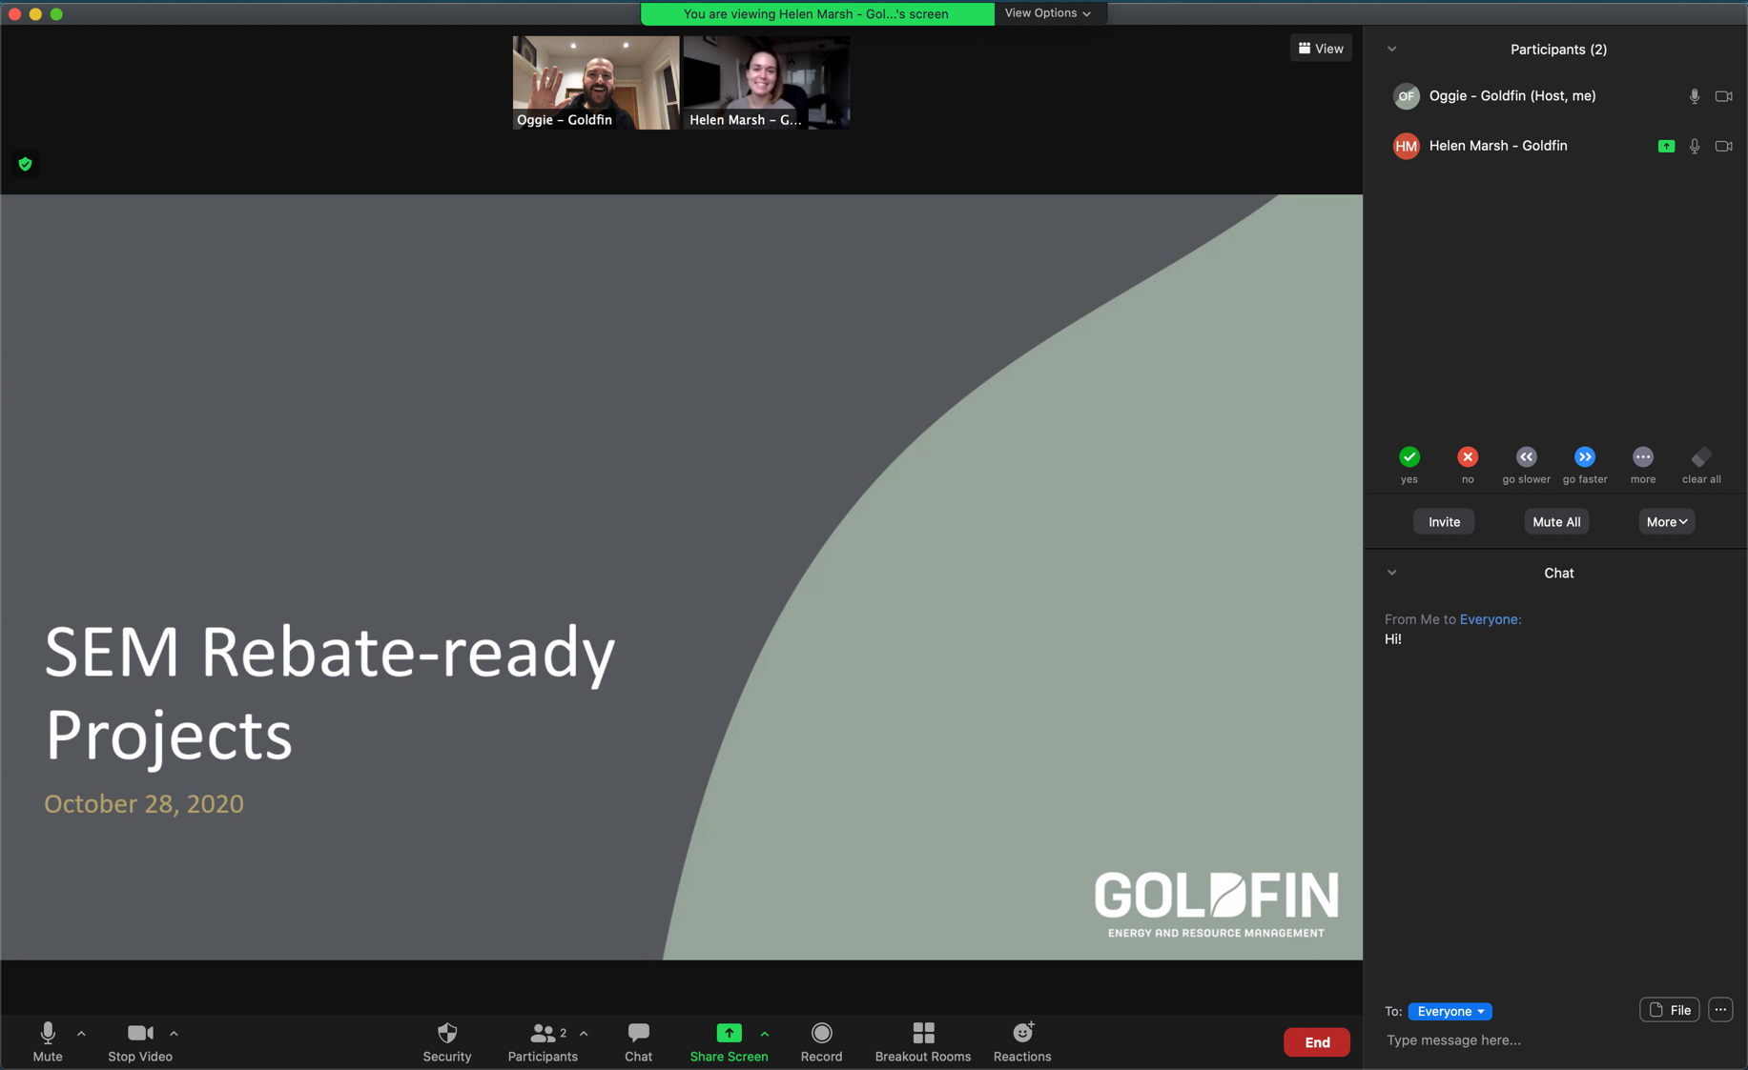

This workshop will provide practical tips, tricks and resources to overcome staffing constraints. You will learn about the key contributors to staffing constraints as well as practical strategies that have proven effective for each. You will establish the next steps to identify, select and implement the most impactful strategy to overcome your specific staffing constraints.

## In this workshop, Participants will:

* Learn the contributing factors and common issues that cause staff constraints within an organization.
* Identify and evaluate strategies to address staff constraints

for specific contributing factors.

* Develop a plan to address staff constraints

in their own organization.

This workshop will be hosted via Microsoft Teams.

For instructions or troubleshooting please   
see the last page of this workbook.

# common Types of staff constraints

## staff availability

Availability refers to team members that would have otherwise been available to support your initiative, however their bandwidth is limited due to competing priorities.

In the space below, write down some examples of how staff availability can present a challenge:

## staff headcount shortage

Headcount shortage refers to a position that would have otherwise been filled, however due to circumstances, the role is vacant (temporary or permanent).

In the space below, write down some examples of how staff headcount shortage can present a challenge:

## staff Knowledge or Skill gap

A knowledge or skill gap refers to a lack of understanding of the technology, analytical processes, or other skills required to successfully implement an initiative.

In the space below, write down some examples of how a staff knowledge or skill gap can present a challenge:

Strategies to Address Staff Constraints

|  |  |  |
| --- | --- | --- |
|  |  | Implementation strategies |
| Business Growth with solid fill | Get more staff |  |
| Clipboard Checked with solid fill | Do more with existing staff |  |
| Share with solid fill | Spread out the work |  |
| Priorities with solid fill | Do less |  |

Breakout room instructions

Each breakout group will work on **one** case study. Select the case study based on the order of your breakout room. For example, breakout rooms 1, 2, and will work on case studies 1, 2, and 3 respectively. Breakout room 4 will work on case study 1, and so on.

In your breakout room, review your case study on the following pages and respond to the question at the end.

breakout group #1: Universities/campuses

You are in a hiring freeze and have a small energy team (3 members) overseeing 33 campus buildings.

They have identified a lot of opportunities, but between the three of them, they don’t have time to monitor and correct setpoints and equipment schedules, stay on top of malfunctions that are wasting energy, as well as managing lighting and other equipment upgrades and preparing their energy reports.

What are some of the ways that the energy team can overcome this staff constraint to ensure efficient operations? Use the space below to keep notes of the strategies discussed during your break-out. Refer to your notes on page 2 for ideas.

breakout group #2: property management

You are the regional manager of a property management company, and the turnover rate of your building managers is high.

As a result of high turnover, building managers have a knowledge gap and often aren’t aware of energy efficient processes or policies, and don’t have the expertise to identify when energy waste is occurring. As a result, HVAC setpoints and schedules are being over-ridden, equipment isn’t being maintained in an efficient state, and in some cases, equipment that was previously retrofitted is being replaced with less-efficient options. In one instance LED bulb were even replaced with incandescent ones!

What are some of the ways that the regional manager can overcome this staff constraint to ensure the energy efficient processes are maintained? Use the space below to keep notes of the strategies discussed during your break-out. Refer to your notes on page 2 for ideas.

breakout group #3: manufacturing

Your energy team was making good progress with multiple capital projects of different sizes underway, audits and studies on specific pieces of equipment, and working with departments to incorporate energy efficiency considerations into their standard procedures.

However, a recent market slowdown has resulted in challenges. While the slowdown is anticipated to be temporary, some staff (including members of the energy team) have been temporarily laid off and capital spending has been frozen. The remaining energy team members are having trouble keeping up with everything that was planned for this year.

What are some of the ways that the energy manager can overcome this staff constraint and ensure energy remains a priority? Use the space below to keep notes of the strategies discussed during your break-out. Refer to your notes on page 2 for ideas.

summary of strategies to address staff constraints

|  |  |  |  |
| --- | --- | --- | --- |
| **Get more staff** | **Do more with existing staff** | **Spread out the work** | **Do less** |
| Make the business case | Attend training | Integrate energy considerations into processes | Respect people’s time |
| Hire lower-cost resources | Improve onboarding | Update standard operating procedures | Only focus on top priorities |
| Explore incentives or funding | Prioritize the most impactful projects | Get energy team contributing | Scale expectations |
| Leverage consultants | Improve processes |  | Caretaker mode |

breakout group: what is your constraint?

Take a few minutes to reflect about the constraint that is most applicable to your situation. What are the specific strategies that you will employ to overcome this constraint. Write down your thoughts in the space below and use this reflection to drive the discussion during the break-out group.

**Your primary staff constraint**:

**Is it temporary or permanent**:

**Strategies you will implement**:

# Getting Started IN TEAMS

This workshop is intended to be highly participatory!

Here are some tips to get the most out of today’s workshop.

## Turn on your camera (if you’re comfortable)

## Unmute or Raise Hand to Speak

While we encourage participants to mute themselves when not speaking to reduce background noise, we encourage everyone to speak up either by raising your hand and/or unmuting yourself.

## Use Menti

There are three different ways for the audience to connect to the Mentimeter presentation and start participating:

* Joining via the join code at [menti.com](https://www.menti.com/)
* Joining via a QR code
* Joining via a join link – this will be provided in the meeting chat.