Pathways to efficient industrial electrification

Participant Workbook

## Industrial organizations are increasingly exploring electrification as a key strategy for reducing greenhouse gas (GHG) emissions. Yet, the path forward is not always clear. Electrification in industrial settings involves unique challenges, from high-temperature process needs to complex system integration and infrastructure limitations.

## This workshop offers a practical, sector-informed roadmap to help industrial professionals identify, assess and begin planning for efficient electrification opportunities. Participants explore proven and emerging technologies, alternatives to traditional thermal processes, key system-level considerations to support effective decision-making and strategies to support electrification plans in the face of uncertainty.

## In this workshop, Participants will:

* Learn about why industrial electrification matters​
* Map temperature-specific opportunities​
* Understand how process changes enable electrification​
* Evaluate common constraints and enablers​
* Understand and apply strategy frameworks

This workshop is hosted via Microsoft Teams.

For instructions or troubleshooting, please   
see the last page of this workbook.

# industrial electrification matters

# What is driving decarbonization?

# Policy momentum: - Canada's Net-Zero by 2050 - Clean electricity regulations - Provincial mandates Economic Pressure: - Uncertain carbon pricing - Energy cost stability - Long-term resilience Market mandates: - ESG disclosure mandates - Supply chain decarbonization demands - Reputation risk

* Canada’s total GHG emissions in 2023 were dominated by energy-related sources.
* Combined, industry-related emissions exceed 50% of Canada’s total.
* Stationary combustion (e.g. industrial heating) is the largest contributor at 43%.
* Transport is the second largest, contributing 28%.
* Industrial sources also include 8% from industrial processes and product use (IPPU).
* Industrial process heating is a key target for electrification and decarbonization.
* Electrifying industrial heat will significantly reduce emissions if paired with clean electricity.

### Why Electrification is a Key Decarbonization Pathway

### Energy-efficiency measures are critical — but not enough on their own. To achieve net-zero, industrial subsectors must directly replace fossil fuel combustion with clean electricity.

**Eliminates on-site combustion**

* Replaces fossil fuel heat with clean electricity
* Essentially eliminates Scope 1 emissions rather than incrementally reducing them through ongoing efficiency efforts

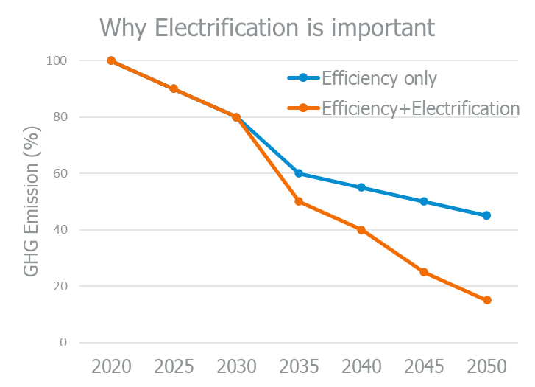**Efficiency alone ≠ net zero**

* Even major efficiency projects (e.g. a 40% natural gas reduction) leave significant residual emissions.
* Remaining fossil fuel use will require offsets or carbon capture — both costly and uncertain.

**Co-benefits beyond emissions**

* Lower maintenance (fewer moving parts, no combustion residue)
* Improved workplace safety (no combustion gases)
* Often higher precision in process control

# NoteS:

# why is industrial electrification not Increasing faster?

|  |  |  |
| --- | --- | --- |
|  | **Infrastructure constraints** | Electrical capacity, aging transformers, limited-service upgradesSite layout/design limitations for new electrical systems |
|  | **Lack of available technologies** | Limited high-temperature electric optionsPerformance gaps for certain applicationsIntegration challenges with existing processes |
|  | **Perceived high costs and low return on investment (ROI)** | Upfront capital costs seen as prohibitiveHigh cost of electricity versus fossil fuels  (spark gap)Short payback thresholds filter out longer-term electrification opportunities |
|  | **Misconceptions/ lack of awareness** | “Electric solutions are not available for high-temperature processes”Confusion between efficiency upgrades versus electrificationUnderestimating co-benefits such as safety or reduced maintenance |

## What do you believe is the biggest barrier to industrial electrification?

# Lack of available technologies

# High upfront costs

# Electrical infrastructure limitations

# No internal support or leadership

# Not a priority right now

# Other:

# Case Study: 3M – advanced manufacturing

* Committed to net-zero GHG emissions by 2050, and they are targeting a 50% reduction in Scope 1 and 2 emissions by 2030.
* One of the most relevant aspects of 3M’s decarbonization strategy is their focus on electrifying process heat, especially in high-precision areas like cleanrooms where they are piloting infrared (IR) drying.
* What is driving this shift? It is not just about carbon, it is also about safety, better process control and responding to investor environmental, social and governance (ESG) expectations.
* They have recognized that efficiency improvements alone will not get them to net zero — electrification is essential.

# Case Study: Cascades – pulp and paper (Canada)

* They have set a goal to reduce Scope 1 and 2 emissions by 38% by 2030.
* Their actions include process redesign to reduce heat demand and shifting from fossil fuel to electric heating and drying systems, especially viable in Quebec where the grid is already 99% clean.
* One takeaway here is how regional grid carbon intensity plays a major role. For Cascades, operating in Quebec allows them to achieve substantial emission reductions by switching to electricity with relatively minor equipment changes.
* Their plan is also supported by provincial electrification incentives, which highlights the importance of understanding local funding programs and policy support.
* Cascades is a great example of combining process change with grid opportunity.

# Case Study: ArcelorMittal Dofasco – steel (Ontario)

* They have committed to a 60% GHG reduction by 2030, primarily through one major shift: replacing coal-based blast furnaces with electric arc furnaces (EAFs).
* This transition alone is projected to cut three million tonnes of CO₂ emissions per year.
* It is important to note that electrifying steel production is capital-intensive, but this project received over $400 million in federal funding through the Strategic Innovation Fund.

**Five pillars of decarbonization stratergies**

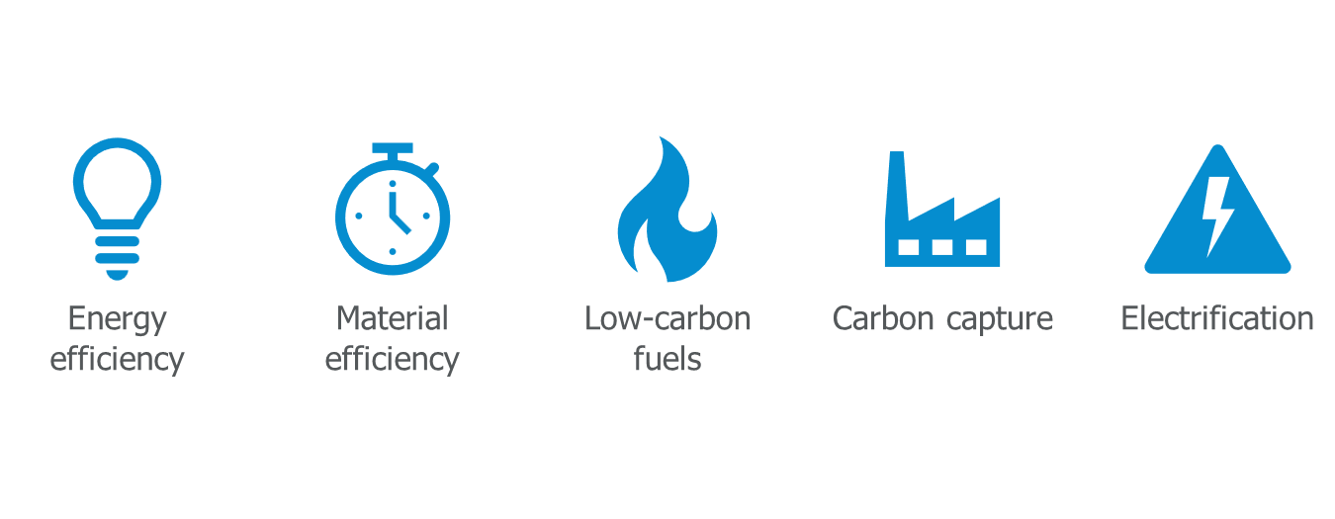

The US Department of Energy’s (US DOE) [Industrial Decarbonization Technology Roadmap](https://www.energy.gov/sites/default/files/2022-09/Industrial%20Decarbonization%20Roadmap.pdf) identifies process temperature as a primary determinant of electrification feasibility.

The roadmap categorizes decarbonization strategies into five pillars (energy efficiency, electrification, low-carbon fuels, carbon capture and material efficiency), but the viability of electrification varies strongly with process heat temperature.

Electrification is most feasible and impactful in low to medium-temperature applications.

Higher-temperature processes will require technological breakthroughs, alternative fuels or non-thermal substitutes in the near term.

**TEMPERATURE DRIVES TECHNOLOGY**

Industrial electrification depends heavily on process temperature, which determines the type of heating application.

|  |  |
| --- | --- |
| 100 ℃ to 300 ℃  **Low temperature**  Common processes include space heating, washing, pasteurization and other low-temperature applications. | 300 ℃ to 800 ℃  **Medium temperature**  Common processes include food processing and paint curing. |
| 800 ℃ to 2000 ℃  **High temperature**  Common processes include metal treatment as well as glass and ceramic production. | >2000 ℃  **Very-high temperature**  Niche applications only |

**BREAKOUT ROOM:**

**In your breakout room:**

1. Discuss what fossil fuel-based heat sources are at your facility
2. Classify each process by heat source and temperature range
3. Estimate the % of total fossil fuel consumption for each

Aim for the best estimates you have today — precision is not required.

|  |  |  |  |
| --- | --- | --- | --- |
| Process | Heat source  (fuel type) | Temperature range | % fossil fuel consumption |
|  |  |  |  |
|  |  |  |  |
|  |  |  |  |
|  |  |  |  |
|  |  |  |  |
|  |  |  |  |
|  |  |  |  |

**ELECTRIC TECHNOLOGIES BY PROCESS TEMPERATURES**

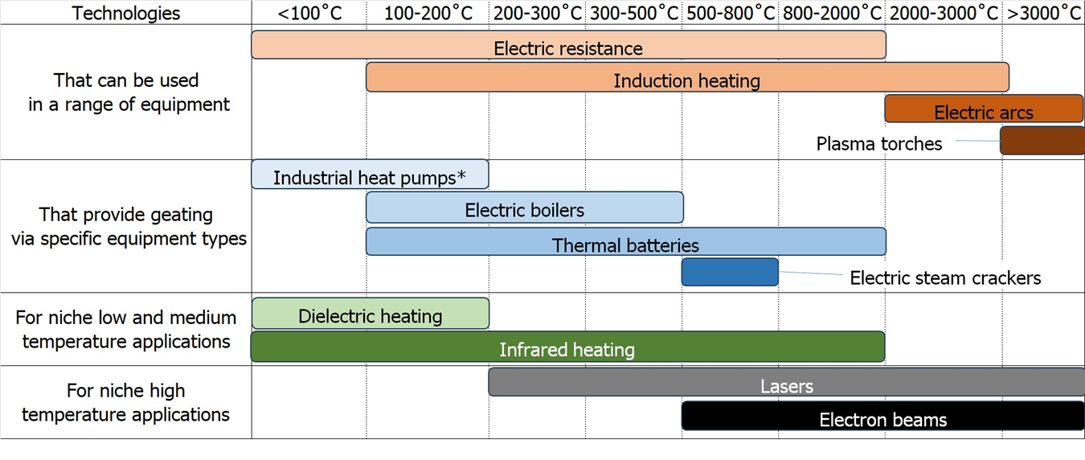

*Up to 160˚C, some up to 200˚C

*Industrial electrified heating technologies and their ranges (image credit: Energy Innovation)*

**INDUSTRIAL HEAT PUMP TECHNOLOGY READINESS LEVEL BY TEMPERATURE RANGE**

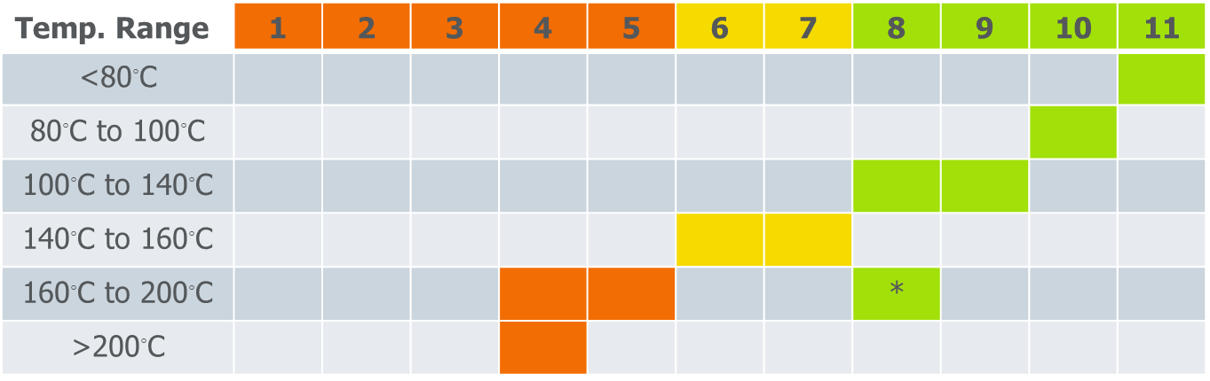

Source: IEA. World Energy Report Special Report. *The Future of Heat Pumps.* 2022

**SECTOR-SPECIFIC SUCCESS STORIES**

**La Brea Bakery (California)**  
Technology adapted: induction heating, temperature range of 2,000˚C with a technology readiness level (TRL) of 11

* Process: transitioned from natural gas convection ovens to electric infrared ovens for artisanal bread baking  
  Outcomes:
* Achieved 30% reduction in energy consumption in the baking process
* Improved bake consistency and reduced warm-up time
* Enabled precise zoning and modular control, reducing waste during start-up and shutdown
* Why it matters: infrared heating delivers fast, efficient heat transfer ideal for surface-dominant processes like baking and toasting.

# What about applications where an appropriate technology is not currently available or FEASIBLE?

* Direct electrification is not always plug-and-play:  
  Many industrial processes are designed around fossil fuel technologies. Simply replacing a gas burner with an electric heater may not be technically feasible, cost-effective or operationally viable.
* Process temperatures often exceed the efficient range of electric technologies:  
  Technologies like heat pumps or electric boilers work well at lower temperatures. If you can reduce the required process temperature, you expand your electrification options and reduce energy demand.
* Electrification can require rethinking the process, not just the equipment:  
  Example: instead of high-temperature, short-duration pasteurization, a facility might switch to longer, lower-temperature processes that are better aligned with electric heat sources.
* Redesign can unlock new non-thermal technologies:  
  Switching from thermal to mechanical or chemical processes (e.g. replacing thermal drying with membrane separation or UV curing) may enable full decarbonization pathways.
* Process redesign supports modular and hybrid systems:  
  Instead of centralized high-heat systems, companies can shift toward modular electric units, improving flexibility, redundancy and capital deployment across facilities.
* Rethinking processes now can futureproof your facility:  
  Making process changes early enables smoother transitions to electrified systems as technologies are improved and policies tightened. It also avoids locking in GHG emissions through long-lived fossil infrastructure.

**FRAMEWORK FOR PROCESS CHANGE TO ENABLE ELECTRIFICATION**

* Many industrial heat applications are designed around fossil fuels.
* Electrification may require rethinking how heat is used, not just what energy source is used.
* The five process-change strategies help unlock electrification where direct substitution is not viable.

## Examples of process changes to enable electrification

|  |  |
| --- | --- |
| Lower temperature alternatives | * Reduce pasteurization temperature but hold at the temperature for longer * Use catalysts or additives to decrease required temperature for reactions or material melting * Lower drying temperature by increasing residence time * Cold sintering for ceramics |
| Mechanical substitution | * Mechanical dewatering (screw presses, centrifuges, belt filter presses, vacuum belt driers) * Mechanical filtration or membrane separation * Self-piercing rivets |
| Non-thermal or chemical alternatives | * UV curing of coatings * Chemical UV or other sterilization approaches * High-pressure processing for pasteurization * Desiccants * Chemical strippers instead of thermal stripping |
| Modular or batch operations | * Replace central boiler with multiple point-of-use heating units * Modular high-turndown efficiency systems to facilitate future hybrid or full electrification |
| Hybrid or transitional systems | * Duel-fuel systems * Electric pre-heating * When doing other work, consider oversizing electrical infrastructure |

**GROUP DISCUSSION – RETHINKING YOUR PROCESS**

**Thinking of your heat sources that may be challenging to electrify**

Refer to:

* Your industrial heat processes you wrote down on page 6.
* The electric heating technologies on page 7 and page 8.

Think about the following and write down your answers:

* Can the process be operated at a lower temperature?
* Can the function be replaced with a mechanical, chemical or non-thermal step?
* Can the process be broken into smaller units or shifted to batch?
* Can the heat source be hybridized as a transitional step?

|  |  |  |
| --- | --- | --- |
| Process | Is there an electric heat source that might be able to replace it? | Is there a potential process change that can help enable electrification? |
|  |  |  |
|  |  |  |
|  |  |  |
|  |  |  |
|  |  |  |
|  |  |  |
|  |  |  |

# Prioritizing and planning your electrification

|  |  |
| --- | --- |
| **Short term** | * Low-cost optimization * Cost-effective efficiency upgrades * Cost-effective electrification, for example:   + Steam tracing   + Applications with production benefits |
| **Medium term** | * End-of-life upgrades * Avoid locking in high-emission systems * Plan for deeper retrofits, for example:   + High-temperature systems   + Process changes |
| **Long term** | * Change processes * Integrate new technologies for high-temperature applications, for example:   + High-temperature heat pumps   + Other technologies |

# Electrification COnstraint Checklist

Use the checklist below to identify site-specific barriers before planning an electrification project. Tick all that apply and note any related details.

**1. Electrical infrastructure**

☐ Limited transformer capacity or service size

☐ Inadequate distribution (e.g. undersized panels, feeders, switchgear)

☐ Utility interconnection delays or complex approval processes

☐ Voltage or power quality limitations for sensitive electric equipment

**2. Process/operational**

☐ Downtime limitations for equipment changeover

☐ Heat source located far from process loads, making conversion complex

☐ Thermal system tightly integrated with other process steps

☐ Variable load profiles that challenge electric technology efficiency

**3. Control systems**

☐ Legacy controls incompatible with electric technologies

☐ No capability for advanced sequencing or demand response

☐ Limited real-time monitoring of process energy use

**4. Economic/financial**

☐ High capital cost versus available budget

☐ Long payback period outside corporate thresholds

☐ Lack of internal carbon pricing or lifecycle cost evaluation

☐ No financial mechanisms for pilot or demonstration projects

**5. Organizational/cultural**

☐ Operator familiarity with combustion systems but not electric systems

☐ Perceived risk of altering established processes

☐ Limited cross-department coordination for decarbonization projects

☐ Competing priorities overshadow GHG reduction goals

**6. External/policy**

☐ Lack of clear regulatory signals or long-term carbon policy

☐ No or limited utility/industry incentives

☐ Uncertainty in fuel/electricity price forecasts

☐ Trade exposure risk if competitors retain cheaper fossil fuel processes

# Electrification Enablers Checklist

Use the checklist below to identify strengths or conditions that could accelerate your electrification projects. Tick all that apply and add notes where relevant.

**1. Ample electrical capacity**

☐ Existing service has spare capacity for added electric loads

☐ Utility has a streamlined upgrade process

☐ On-site substation or feeders sized for future load growth

**2. Clean, low-cost grid electricity**

☐ Low-carbon intensity electricity (e.g. BC, Quebec, Manitoba)

☐ Competitive rates versus fossil fuel costs

☐ Time-of-use or demand response pricing that benefits electrification

**3. Planned capital projects**

☐ Major thermal equipment near end of life

☐ Planned facility expansion, modernization or reconfiguration

☐ CAPEX budget placeholders for enabling infrastructure

**4. Supportive leadership and culture**

☐ Executive commitment to GHG reduction and net-zero targets

☐ Sustainability key performance indicators (KPIs) in corporate performance metrics

☐ Internal champions with authority to move projects forward

**5. External incentives and funding**

☐ Utility or provincial retrofit incentive programs

☐ Federal decarbonization funding (e.g. Strategic Innovation Fund, Clean Growth Program)

☐ Low-interest financing for clean technology adoption

**6. Proven technology fit**

☐ Vendor solutions demonstrated in similar processes

☐ Peer case studies available with performance and ROI data

☐ Technology maturity level supports immediate deployment

**FROM INSIGHT TO ACTION: BUILDING YOUR ELECTRIFICATION STRATEGY**

**UNCERTAINTY AS A PLANNING FACTOR**

Uncertainty is inevitable
Manage, don't avoid
Scenario thinking
Risk of inaction

**Uncertainty is inevitable** – Technology gaps, policy shifts or market volatility are normal in long-term industrial planning, especially for electrification.

**Manage, do not avoid** – Instead of waiting for perfect clarity, use adaptive planning, staged investments and pilot projects to move forward while remaining flexible.

**Scenario thinking** – Develop multiple pathways (e.g. electrify now versus wait for next generation technology) and assess the triggers that would cause you to shift course.

**Risk of inaction** – Delaying without a plan can lock in fossil fuel infrastructure, raise future compliance costs and reduce competitiveness.

**Strategy Framework for Industrial Electrification Planning**

This framework helps facilities plan electrification efforts strategically, accounting for uncertainty, constraints and long-term capital planning cycles.

1. **Start with what can be done now**

* Identify low-risk, high-impact opportunities (e.g. replace fossil fuel-based makeup air unit, add controls)
* Focus on quick wins that are aligned with current maintenance or operations budgets
* Bundle with existing initiatives (e.g. energy efficiency, ESG targets)
* Consider co-benefits: maintenance reduction, process control, safety

**2. Identify knowledge or technology gaps**

* List processes or end-uses wherein electrification is desirable but not immediately feasible
* Determine whether a limitation is due to technology maturity, lack of internal expertise or product/process validation requirements
* Plan to address through:
  + - Pilot projects
    - Vendor engagement
    - Research partnerships
    - Site-specific studies

**3. Build in decision gates and triggers**

* Connect electrification opportunities to capital asset timelines:
  + - Equipment nearing end of life
    - Facility expansion or renovation
    - Scheduled CAPEX planning windows
* Define triggers for revisiting decisions:
  + - Carbon price threshold
    - New incentive program launch
    - Demonstration project success
    - Equipment failure or retrofit opportunity
    - Use structured decision frameworks to assess readiness (e.g. go/no-go checkpoints)

**4. Design for flexibility and avoid lock-in**

* When replacement with electrified systems is not feasible now:
  + - Choose modular or hybrid systems that can evolve
    - Oversize electrical panels for future electrification
    - Design pipe chases, ducting or spaces for future equipment
* Avoid re-investing in long-life fossil systems unless future adaptation is possible

**5. Integrate with broader business planning**

* Align electrification with:
  + - five or 10-year capital planning
    - ESG or compliance milestones
    - Facility lifecycle assessments
* Budget for enabling infrastructure (e.g. transformers, control systems)
* Communicate internally to ensure electrification is part of strategic conversations early on

**BREAKOUT ROOM INSTRUCTION**

Reflect on and discuss the following questions with your group. Take takeaway notes below:

* + - * What could be electrified in the next few years?
      * For which key decision gates will you need to plan?
      * How will you avoid locking in GHG emissions?

# For more information

## Save on Energy

* [Training and Support: Decarbonization Strategies](https://saveonenergy.ca/Training-and-Support/Decarbonization-Strategies).
* [Introduction to Efficient Electrification Toolkit](https://saveonenergy.ca/-/media/Files/SaveOnEnergy/training-and-support/ee/Introduction-to-the-Efficient-Electrification-Toolkit-Fact-Sheet.pdf).
* [Integrated Design Best Practices Guide - Industrial](https://saveonenergy.ca/-/media/Files/SaveOnEnergy/training-and-support/ee/The-Integrated-Design-Process-Best-Practice-Guide-for-Industrial-Facilities.pdf).
* [Integrating EV Charging in Buildings](https://saveonenergy.ca/-/media/Files/SaveOnEnergy/training-and-support/ee/Fact-Sheet-Integrating-EV-Charging-in-Buildings.pdf).

## US Department of Energy

* [Industrial Decarbonization Roadmap. 2022.](https://www.energy.gov/sites/default/files/2022-09/Industrial%20Decarbonization%20Roadmap.pdf)
* [Better Buildings. The (not so) shocking shift toward industrial electrification](https://www.youtube.com/watch?v=U-xECp3kefw) (2024 webinar recording).
* [Better Plants. Industrial Electrification Assessment Framework. 2025.](https://www.smartenergydecisions.com/research/industrial-electrification-assessment-framework/)

## Other Resources

* [Industrial Heat Pump Alliance.](https://industrialheatpumpalliance.org/)
  + [Industrial heat pump procurement toolkit](https://industrialheatpumpalliance.org/ihp-procurement-toolkit/).
* [Agora Industry. Direct electrification of industrial process heat: An assessment of technologies, potentials and future prospects for the EU. 2024.](https://www.agora-industry.org/fileadmin/Projects/2023/2023-20_IND_Electrification_Industrial_Heat/A-IND_329_04_Electrification_Industrial_Heat_WEB.pdf)
* [ACEEE. Industrial Heat Pumps.](https://www.aceee.org/industrial-heat-pumps)
* [ACEEE. Industrial Heat Pump Domestic Market. 2023.](https://www.aceee.org/sites/default/files/pdfs/IHP_Workshops_2023/EER_Workshops/ACEEE%20Slides%20-%20IHP%20Workshop%20at%20EER.pdf)
* [ACEEE. A scenario analysis of boiler replacement with industrial heat pumps. 2024.](https://www.aceee.org/topic-brief/2024/12/net-zero-industry-2050-scenario-analysis-boiler-replacement-industrial-heat)
* [ACEEE. The industrial heat pump opportunity goes beyond energy savings. 2024.](https://www.aceee.org/topic-brief/2024/06/industrial-heat-pump-opportunity-goes-beyond-energy-savings)
* [ACEEE. Using Industrial Heat Pumps to Rethink Thermal Loads. 2024.](https://www.aceee.org/topic-brief/2024/02/stop-waste-use-industrial-heat-pumps-rethink-thermal-loads)