XLERATE PROGRAM
MEASUREMENT AND VERIFICATION PLAN TEMPLATE
PURPOSE
This template is designed to support Participants and their Consultants in preparing a Measurement and Verification (M&V) Plan that aligns with the requirements of the Save on Energy XLerate Program as well as the International Performance Measurement and Verification Protocol (IPMVP) Core Concepts, March 2022, EVO 10000–1:2022. It provides clear guidance on developing an IPMVP-compliant M&V Plan, including the methodology and procedures for establishing the baseline, adjusted baseline, and reporting period energy.
Use of this template is not mandatory; however, it is strongly recommended. By following this structure, Participants can prepare clear, complete, and consistent submissions that minimize the need for information requests from the Technical Reviewer, streamlining the overall review process.
Within this template:
- Black text represents highly suggested, standard language. Participants and their Consultants are encouraged to retain this in their M&V Plan, as it outlines the fundamental requirements of the Plan and provides consistent structure, standard headings, and required sections. Participants may propose reasonable revisions to this text, subject to review and approval by the Technical Reviewer.
- Blue text is explanatory in nature. It provides prompts, examples, and guidance to help Participants and Consultants understand the expectations for specific M&V Plan sections. This content should be reviewed carefully and replaced with Project-specific details before submission.

If you require additional support in developing your M&V Plan, please contact your IESO Representative. The IESO provides comprehensive M&V support to XLerate Program Participants.

XLERATE PROGRAM MEASUREMENT & VERIFICATION PLAN

PARTICIPANT NAME
PROJECT DESCRIPTION

DATE
Revision 0

Project ID:
Application Number, as provided by the IESO/Technical Reviewer

Prepared for:
The Independent Electricity System Operator (the IESO)

Prepared by:
Participant’s Legal Name

Written by:
Name
Signature
Date

Reviewed by (as applicable):
Name
Signature
Date

Participant Acknowledgement:
Name
Signature
Date

Revision History
Date | Description | Revision | Author
 | M&V Plan First Issuance | 0

Contents
Introduction 5
Project Synopsis 5
System and Project Description 6
A. Data Collection 6
A.1. Participant Action Items 7
A.2. Metering and Data Collection 7
A.3. In-Service Date 9
A.4. Timetable 10
A.5. Calibration Requirements 11
B. M&V Analysis and Reporting 11
B.1. TEChnical Reviewer Action Items 11
B.2. M&V Reports 12
B.3. Methodology and Procedure 12
B.4. Data Management, Reporting Format and Quality Assurance 18

Introduction
This measurement and verification plan (M&V Plan) has been prepared in accordance with the IPMVP Core Concepts. The M&V Plan states the approach and methodology for verification of the Electricity Savings achieved by the Project.
The M&V Plan is divided into two main sections where:
- The first section (A) contains all information and direction that will assist the Participant in fulfilling their responsibilities to meter and collect the required metered data for the Project.
- The second section (B) sets out the subsequent analysis, calculations, models, and reporting that are the responsibilities of the Participant as well as defines the role of the Technical Reviewer.

Project Synopsis
Participant: Participant ’s Legal Name
Facility Type: Brief sector description (e.g. steel, automotive, institutional)
Project Title: Brief title of project (e.g. Chiller system optimization).
Baseline Period Energy: XXXX MWh/year
Anticipated Electricity Savings: XXXX MWh/year
IPMVP Option Selected: IPMVP Option A, B, C, or D
Estimated In-Service Date:
Reporting Period: One year from the In-Service Date

System and Project Description
The M&V Plan should include a description of the facility, any relevant systems, the proposed project, and a list of the measures being implemented. References to supporting documents, such as energy audit reports or other analyses used to define the project scope are useful to provide context.
For each measure, the Plan should outline its scope, intent, and an explanation of how the measure(s) save energy.
Include a figure describing the measurement boundary for the Baseline Equipment. An example is provided below.

Figure 1: Baseline Equipment and Measurement Boundary
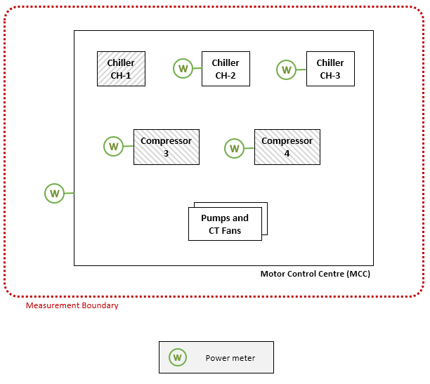

A. Data Collection

A.1. Participant Action Items
The Participant is responsible for:
- Installing meters to collect metered data as specified in Table 1 with a minimum of 3 significant digits. The Participant will endeavour to ensure that metered data is recorded continuously and without missing periods.
- Calibrating the electrical and process meters or verifying their accuracy if meter calibration is not possible, as specified in Section A.5.
- Providing at least one week of metered data and corresponding savings calculations to the Technical Reviewer before the confirmation of the In-Service Date (ISD). If any data collection issues are discovered or the metered data does not comply with this M&V Plan, the Participant will correct them in a timely manner.
- Providing the Technical Reviewer and the IESO with reasonable access to the Facility in order to observe the measures in normal operation and to confirm the ISD, as specified in Section A.3.
- Remitting metered data and savings calculations to the Technical Reviewer and the IESO at the end of each period as specified in Table 2, for the 1st Quarterly / 1st Annual Reporting Period, in a Microsoft Excel format with a date and time stamp for each data point. This data and calculation spreadsheet will support the required 1st Quarterly / 1st Annual Reporting Period M&V Reports which are also a responsibility of the Participant.
- Informing the Technical Reviewer or the IESO of any significant process changes related to Non-Routine Adjustments as described in Section B.3.4.

A.2. Metering and Data Collection

A.2.1. Before Any Change to the Existing Equipment – Baseline Period
The M&V Plan should summarize the metering approach used to establish the Baseline Period Energy. Where additional actions are required to refine the baseline, these should be described. The Plan should also outline the metering points used, the accuracy of the meters used to measure the Baseline Period Energy, and the duration of the Baseline Period.

A.2.2. After the In-Service Date – Reporting Period
The Participant must collect and provide the metered data to the Technical Reviewer or the IESO as specified in Table 1.

Table 1. Metering Requirements of the Reporting Period
Equipment or Variable | Measurement Requirement
Equipment or Variable | Qty | Installation Required? | Type | Interval | Parameter | Units
Equipment 1 | 1 | Yes | Continuous | Hourly | Power | KW
Equipment 2 | 1 | Yes | Continuous | Hourly | Power | KW
Cooling Load | 1 | No | Continuous | Hourly | Energy | BTUH

A.2.3. Meter Location and Measurement Boundaries
Figure 2 shows the equipment after the installation of the measure. Metering points are as per Table 1 above.

Figure 2: Reporting Period Equipment and Measurement Boundaries

A.2.4. Metered Data Retention
For the purpose of M&V Reporting, the Participant is required to collect and retain the metered data specified in Table 1 for the duration of the Reporting Period. The XLerate Program Requirements and Project Terms and Conditions provide further details on retaining meter data beyond the Reporting Period.

A.3. In-Service Date
The ISD represents the first day that a Project is fully installed in accordance with the M&V Plan and delivers Electricity Savings. The ISD is established with agreement amongst the Participant, the IESO, and the Technical Reviewer.
The establishment of the ISD has two milestones:
- Facility Visit: The Technical Reviewer and/or the IESO will visit the Facility to:
  - Witness the new equipment as described in this document.
  - Witness the new meters installed for this Project and detailed in Table 1.
  - Confirm that the data collection system is running and acquiring the metered data.
  - Verify that the metered data obtained from the data collection system is matching the metered data requirements of this M&V Plan.
  - Acquire photographs of the new equipment and meters.
  - Obtain copies of the calibration certificates, if any.
  - Meet with the Participant to answer questions related to the M&V Reporting Period activities.
At the IESO’s sole discretion, evidence provided by the Participant may be acceptable in lieu of a Facility Visit.
- Remittance of at least one week of metered data and corresponding savings calculations that are compliant with the M&V Plan.
Note that the ISD can be a date prior to the date of the Facility Visit.

A.4. Timetable

A.4.1. Schedule of Reporting Activities
The Reporting Period starts from the confirmed ISD and lasts one year. The Participant must remit the metered data for the confirmation of the ISD, at the end of the 1st Quarterly Period (alongside the Q1 M&V Report) and the end of the 1st Annual Period (alongside the Y1 M&V Report), as stated in Table 2. Additional details on the M&V Reports and Reporting Periods can be found in Section B.2.
Table 2: Reporting Activities
Schedule | Estimated Date
In-Service Date | Estimated ISD
Start of the M&V Reporting Period | Same day as ISD
End of the M&V Reporting Period | 1st Anniversary of the ISD
M&V Site Visit by the Technical Reviewer | Within a month of the proposed ISD
Remittance of metered data and corresponding savings calculations for the confirmation of the ISD | Within a month of the proposed ISD
Remittance of the 1st Quarterly metered data and corresponding M&V Report | 3 months after the ISD
Remittance of the 1st Annual metered data and corresponding M&V Report | 1 year after the ISD

A.5. Calibration Requirements

A.5.1. Before the In-Service Date
Describe calibration process and supporting documentation submitted to the Technical Reviewer for the baseline measurements. If further documentation is required, the Technical Reviewer will advise accordingly.

After the In-Service Date
The Participant is required to provide calibration certificates and documentation on the accuracy class of the meters listed in Table 1.
Note that calibration certificates are not required if the meter manufacturer can provide written statements that its meters do not require calibration.

B. M&V Analysis and Reporting

B.1. TEChnical Reviewer Action Items
The Technical Reviewer is responsible for:
- Confirming the ISD after agreement with the Participant and the IESO.
- Reviewing the M&V Report provided by the Participant for each period in accordance with Table 3. This includes:
  - Confirming IPMVP-compliance and adherence to this M&V Plan.
  - Reviewing the metered data of the Baseline Period and Reporting Period provided by the Participant.
  - Reviewing all calculations, including for the Baseline Period Energy, Adjusted Baseline Period Energy, Reporting Period Energy, Electricity Savings and Summer Peak Demand Savings.

B.2. M&V Reports
At the end of each Reporting Period defined in Table 3, the Participant shall issue an M&V Report to the IESO. If delays to the ISD are expected for any circumstances, the IESO and Technical Reviewer shall be notified. At the IESO’s discretion, the subsequent M&V Reports may be postponed by an amount equal to the delay.

Table 3: M&V Reports
M&V Reports | Reporting Periods
1st Quarterly | ISD to ISD + 3 months
1st Annual | ISD to ISD 1st Anniversary
The IESO may require additional M&V Reports for the Project and extend the applicable M&V Reporting Period in its sole discretion.

B.3. Methodology and Procedure
This section specifies the calculation methodology, data analysis procedure, and assumptions that are used for calculating the Electricity Savings. The following items are presented:
- Summary of the baseline equipment and metered data, including the Baseline Period Energy applicable only to the conditions of the Baseline Period.
- The model used for adjusting the Baseline Period Energy, due to changed conditions of the Reporting Period from the Baseline Period.
- The calculations of the Reporting Period Energy.
- The calculations of the Electricity Savings, which are defined as:
Electricity Savings | = | Adjusted Baseline Period Energy | – | Reporting Period Energy | ± | Non-Routine Adjustments

B.3.1. Summary of the Baseline Equipment and Metered Data
The details of the assessed Baseline Period Energy are presented below, with adherence to the IPMVP.
IPMVP Option:
Declare the IPMVP Option (A, B, C or D) selected for this M&V Plan.
Measurement Boundaries:
Inventory of Baseline Equipment including equipment size, type, quantity, and equipment tags. Reference to Figure 1 and inclusion of a summary table can be helpful for large or complex systems.

Interactive Effects beyond the Measurement Boundaries:
Interactive Effects are defined as energy impacts from an energy efficiency measure that occur outside of the measurement boundary and are not included in the measured savings.
Statement of Interactive Effects beyond the Measurement Boundaries if any, including a description of how these interactive effects are accounted for in the assessment of Baseline Period Energy. If no Interactive Effects are expected in the assessment of Baseline Period Energy this should be clearly stated in text similar to the following:
“No Interactive Effects beyond the Measurement Boundaries were identified. If an Interactive Effect is discovered later during the Baseline Period or the Reporting Period, the Interactive Effect should be taken into account in the energy calculations.”
Collected Baseline Data:
Details on the collected baseline data for each item in the Baseline Inventory are expected to include the parameters measured and the measurement interval.

Baseline Period:
Define the baseline measurement period. It is expected that the Baseline Period conforms with IPMVP Guidelines and should be representative of a complete operating cycle.
Baseline Period Summer Peak Demand:
The Peak Demand Period is defined as weekdays, 3 pm – 9 pm, June 1 to September 30. The Baseline Peak Demand is calculated using the equation below:
Eq. 1 Baseline Period Summer Peak Demand (kW) = Average demand during the summer peak period (weekdays, 3 pm – 9 pm, June 1 – September 30)
Summary of Baseline Period Energy:
Statement of the annual Baseline Period Energy in MWh/year.
A description of how the Baseline Period Energy was assessed. Depending on the complexity of the baseline this could be as simple as the formula below, or may require additional text, graphics, or formulas to adequately communicate the assessment of the Baseline Period Energy.
Eq. 2 Baseline Period Energy (MWh) = Sum of hourly metered [Equipment 1 Power + Equipment 2 Power] over the Reporting Period
Where multiple pieces of equipment are included in the baseline, a table similar to the example below can be useful to summarize the Baseline Period Energy.

Table 4: Summary of Baseline Period Energy
System | Based on | Baseline Period Energy (MWh)
Equipment 1 | Annual meter Data | 78,405
Equipment 2 | Extrapolated based on metered hours of operation | 5,236
Total |  | 83,641

B.3.2. Adjusted Baseline Period Energy
Operating conditions that influence energy consumption are likely to vary between the Baseline Period and the Reporting Period. To ensure a valid comparison, the M&V Plan should describe how energy consumption and demand will be adjusted for these differences. This section defines the approach used to normalize data and calculate energy savings under comparable conditions.
Baseline adjustments may be established by projecting baseline energy consumption and demand to Reporting Period conditions, projecting Reporting Period consumption and demand to baseline conditions, or projecting both periods to a common set of standard conditions, such as a typical meteorological year. The choice of adjustment approach will determine whether savings are expressed as avoided energy or as normalized savings.
This section should provide enough detail to clearly explain the baseline adjustment approach, including the equations that will be applied and the statistical validity of any models used. Supporting materials such as tables, graphs, or other references are encouraged to illustrate the methodology. Examples of suitable headings and figures are included below for guidance; however, they may not apply in all situations. Authors are expected to add or remove content as appropriate for the specific project.
Correlation with an independent variable
A typical approach to baseline adjustment is to establish a relationship between energy consumption and an independent variable through linear correlation. For weather dependent equipment, a correlation to cooling degree days (CDD) or heating degree days (HDD) can often be found. An example is included below for reference.

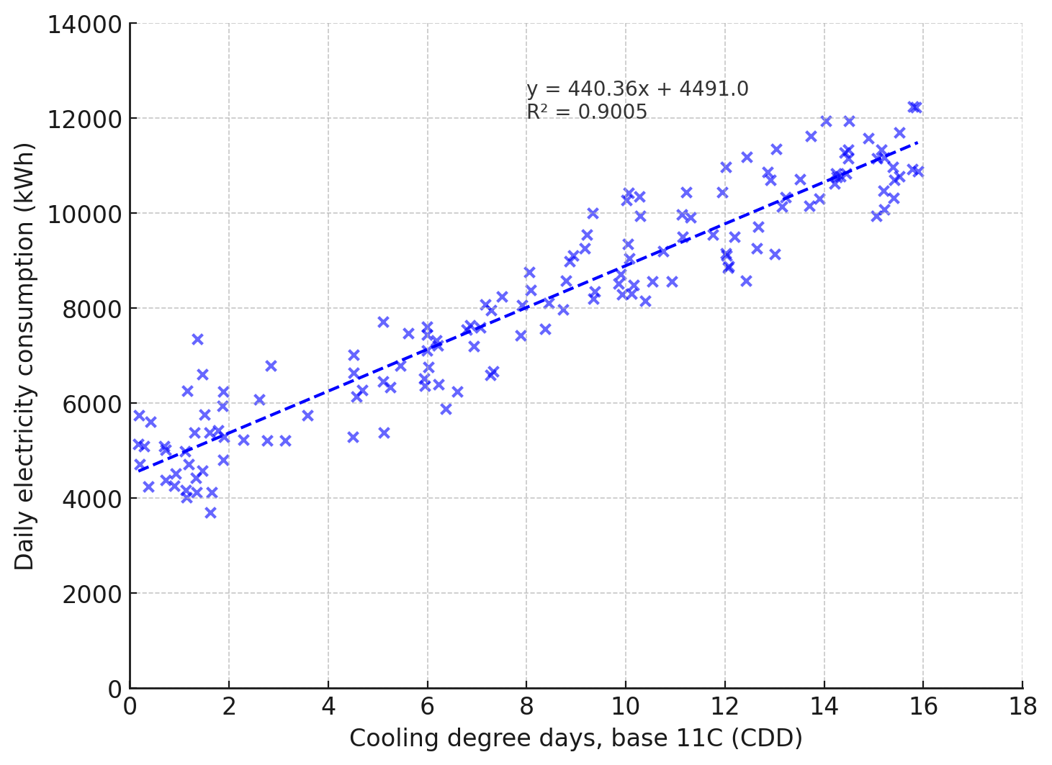

Note that Linear Regression correlations are not the only acceptable means of baseline adjustments. The M&V Plan author may present any means of baseline adjustment which conform with IPMVP Guidelines and good engineering practice, provided they supply sufficient evidence of the statistical validity of the approach.

Adjusted Baseline Period Energy Equations:
The Baseline Period Energy model is defined by the following equations:
Eq. 3 Adjusted Baseline Period Energy (MWh) = Sum of (440.36 × Daily Cooling Degree Days + 4491.0) over the Reporting Period (daily)
Uncertainty of the Adjusted Baseline:
Provide a statement of the Uncertainty of the Adjusted Baseline, as applicable. A Confidence Interval of 90% should be used in all cases. Include information on the sources of Uncertainty and how the Adjusted Baseline Uncertainty value was determined.

B.3.3. Reporting Period Energy
This section provides the methodology and equations that will be used to calculate the Reporting Period Energy and process parameters of the measure.

Measurement Boundary:
Inventory of Reporting Period Equipment including equipment size, type, quantity, and equipment tags. Reference to Figure 2 and inclusion of a summary table can be helpful for large or complex systems.
Reporting Period Energy Equations:
The Reporting Period Energy will be calculated using the following equation:
Eq. 4 Reporting Period Energy = Reporting Period Energy (Equipment 1) + Reporting Period Energy (Equipment 2)
Where,
Eq. 5 Reporting Period Energy (Equipment 1) = Sum of Hourly Metered (Equipment 1) Power over the Reporting Period
Eq. 6 Reporting Period Energy (Equipment 2) = Sum of Hourly Metered (Equipment 2) Power over the Reporting Period

Uncertainty of the Reporting Period Energy:
Provide a statement of the Uncertainty of the Reporting Period Energy. A Confidence Interval of 90% should be used in all cases. Include information on the sources of Uncertainty and how the Reporting Period Energy Uncertainty value was determined.
Reporting Period Summer Peak Demand:
The Reporting Period Peak Demand will be calculated using the equation below:
Eq. 7 Reporting Period Summer Peak Demand (kW) = Average demand during the summer peak period (weekdays, 3 pm – 9 pm, June 1 – September 30)

B.3.4. Non-Routine Adjustments
Non-Routine Adjustments are defined in the IPMVP Core Concepts. These adjustments are usually made just once during the Reporting Period for factors that are not expected to change (i.e. Static Factors). They must be monitored for change throughout the reporting period and already collected in the Baseline Period. The following could be considered changes in Static Factors, as applicable:
- Change in the design and operation of installed equipment.
- A significant process change related to the system operation will result in an assessment whether to re-adjust the Baseline Period Energy and/or the Reporting Period Energy. The process change may include the addition, modification, or removal of equipment related to the measure.
- Other changes relating to the processes, operations or equipment that, as reasonably determined, could affect the performance of the measure.
Where a Non-Routine Adjustment is applied, it must be done using good engineering practice and following the guiding principles of the IPMVP.
Static Factors identified for Project
The Participant should identify business-specific or measure-relevant Static Factors and provide the method for recording them.

B.3.5. Electricity Savings and Summer Peak Demand Savings
The Electricity Savings are calculated as shown at the beginning of Section B.3.
Anticipated Electricity Savings represent the Project’s estimated reduction in electricity consumption and are pro-rated to the duration of the applicable M&V Reporting Period (e.g., Q1 or Y1).
The Anticipated Electricity Savings (annual) are: XXXX MWh.
For seasonal or other measures with variable impact throughout the year, the Anticipated Electricity Savings should be defined on a monthly basis in Table 5 and subsequently referenced in the corresponding M&V Report. Table 5 and this text should otherwise be deleted.
Table 5 below provides a summary of the Anticipated Electricity Savings:

Table 5: Breakdown of Anticipated Electricity Savings
Month | Anticipated Electricity Savings (MWh)
January | XXX MWh
February | XXX MWh
March | XXX MWh
April | XXX MWh
May | XXX MWh
June | XXX MWh
July | XXX MWh
August | XXX MWh
September | XXX MWh
October | XXX MWh
November | XXX MWh
December | XXX MWh
Total | XXXX MWh

Uncertainty of the Electricity Savings:

Provide a statement of the Uncertainty of the Electricity Savings. A Confidence Interval of 90% should be used in all cases. Include information on the sources of Uncertainty and how the Electricity Savings Uncertainty value was determined. The Uncertainty of Electricity Savings must be ≤ ±25% at a 90% Confidence level, unless otherwise approved by the IESO.
The Uncertainty will be re-calculated when M&V Reports are issued and based on actual results.
Summer Peak Demand Savings:
The Summer Peak Demand Savings will be calculated as:
Eq. 8 Summer Peak Demand Savings (kW) = Baseline Period Summer Peak Demand (kW) - Reporting Period Summer Peak Demand (kW)
Note that the Baseline Summer Peak Demand will be adjusted to the conditions of the Reporting Period, similar to the Adjusted Baseline Period Energy equations in Section B.3.2.
Where granular data is not available for the Baseline Period Summer Peak Demand and/or the Reporting Period Summer Peak Demand, Participants may use a weighting method using design load to calculate Summer Peak Demand Savings for weather-dependent measures (provided sufficient load data is available). Table 6-2 of the IESO’s Evaluation, Measurement and Verification (EM&V) Protocol (V5.0) provides further details on these weightings.

B.4. Data Management, Reporting Format and Quality Assurance

B.4.1. Data Cleaning and Quality
This section describes the general methodology of the metered data analysis to be used to calculate the Electricity Savings. As thousands of data records are collected and analysed for a Reporting Period, the following key points provides information on how the data should be filtered, cleaned, transformed, or converted:
- Missing or bad data: if the data represents a small portion (usually less than 10%) of the total dataset, the available data will be extrapolated to the entire Reporting Period. If the missing data represents a larger portion, either:
  - extrapolate the available data if the operation of the System is steady, predictable or repeatable, or if other parameters are available to prove the operation of the System, or
  - set the Electricity Savings to “nil” if no other parameter is available to prove the operation of the System, or
  - extend the Reporting Period by an amount equal to the duration of the missing data.
The Participant will provide the reason of the missing data, and document reasonable steps to prevent future occurrences of missing data.
- Outliers: they are points that are not representative of the System or process because of process upsets or unusual events and represents a small portion of the total dataset. They are removed from the analysis if it can be reasonably demonstrated that they are not representative of the System or process.
- Unit conversion: the metered data can be provided in units different than stated in this document, with the data being converted to the proper unit for the analysis and calculation of the electricity savings.
- Filtering: the metered data can be filtered to accommodate for cases when a specific value is not possible. For example, negative power values will be replaced with zero values.

- Resampling: datasets that are unusually large due to large number of parameters or small intervals (less than hourly) will be resampled to a smaller dataset to simplify the analysis while maintaining the accuracy of the results.
- Model valid range: the inputs to the baseline energy model have a range limited to the independent variable range of the baseline data, extended by a maximum of 10% on both ends of the range. If the inputs from the Reporting Period are outside of that range, the inputs will be capped to the upper end of the range, plus 10%.

B.4.2. Monitoring and Reporting Responsibilities
The monitoring and reporting responsibilities for collecting, analyzing, archiving and reporting the data are as follows:

Table 6: Monitoring and Reporting Responsibilities

Monitoring and Reporting Activity | Monitoring and Reporting Responsibility
Acquisition of Energy and Independent Variable Data | Individual name, group or title
Management of measurement equipment and systems | Individual name, group or title
Monitoring of Static factors impacting energy use within the measurement boundary | Individual name, group or title
Operational verification, periodic inspections and quality assurance activities | Individual name, group or title
Analysis and retention of acquired data | Individual name, group or title
Preparation and publication of M&V Reports | Individual name, group or title

B.4.3. M&V Report Format
Each M&V Report will be provided in a format similar to that prescribed in Section 13.3 of the IPMVP Core Concepts (March 2022).

B.4.4. Quality Assurance Activities
To ensure accuracy, consistency, and credibility of all M&V efforts, the following quality assurance (QA) activities will be implemented:
- Peer Review of M&V Reports: Each draft M&V report will undergo a formal peer review by a qualified team member not directly involved in the analysis. This review will assess clarity, completeness, and alignment with the M&V Plan and relevant protocols.
- Technical Review of Calculations: All energy and calculations, including baseline adjustments, savings calculations, and uncertainty analyses, will be subject to an independent technical review. This includes cross-checking formulas, verifying assumptions, and confirming data integrity.
- Version Control and Documentation: All versions of reports and supporting data will be tracked through version control protocols to ensure traceability.
- QA Sign-Off Prior to Submission: Reports will not be finalized or submitted to the IESO/Technical Reviewer until all QA activities are completed and signed off by the Participant.

